1.Invalid User:

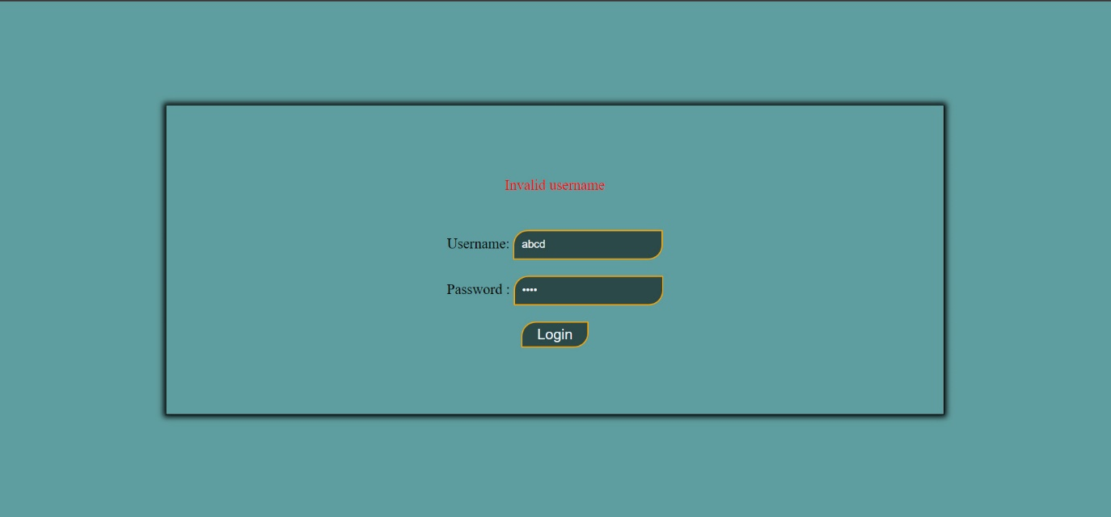

2.Correct User Id: (Username ,Password = “G1S11”)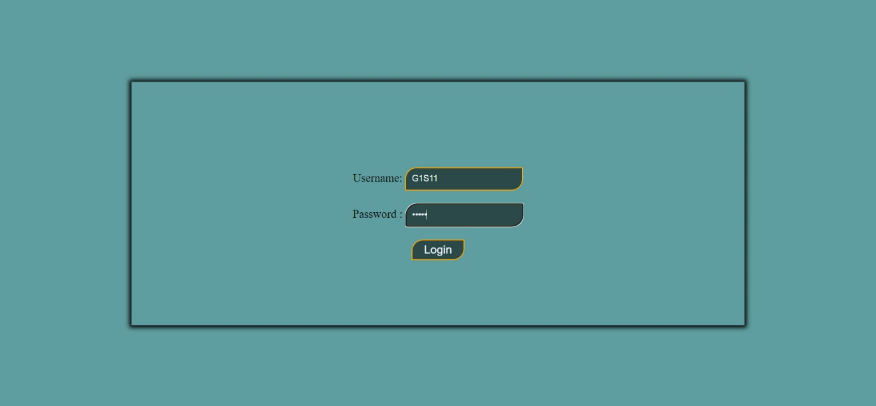

3.Resume Page when index =1 hide previous btn:

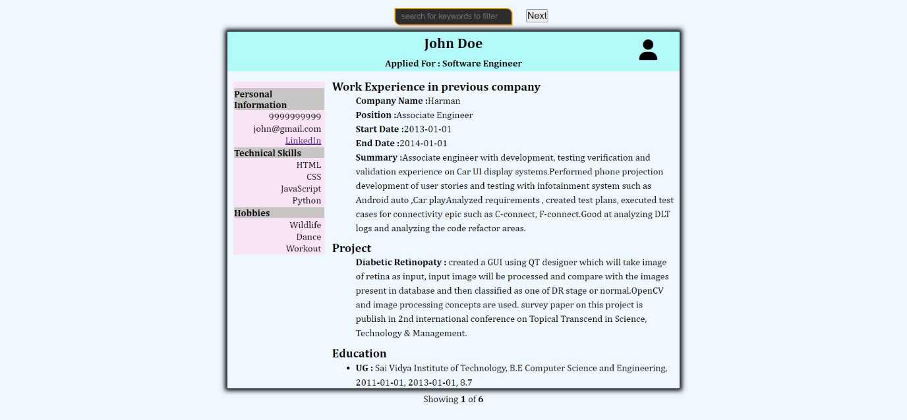

4.When index is one and above next btn visible: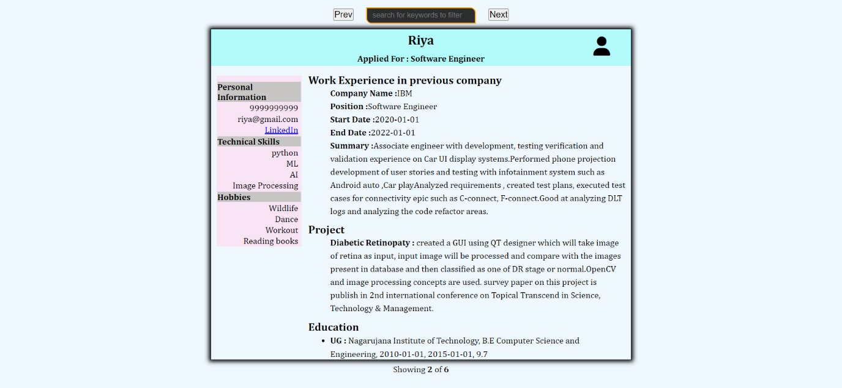

5.Error Message when mismatched keywords: